Creating a content package with 6 UI cards

For the first part we need to create a content package with some UI cards fully in VS code, and deploy it to SAP work zone.
Here is a guide of how I did it.
Creating a content package from vs code

- Setting up the environment
For the project I used the latest version of Visual Studio Code as well as the SAP BAS
https://code.visualstudio.com/

After completing it we need some extensions

- Extensions
- SAP Fiori Tools Extension pack
This includes everything we need, such as the remote – SSH.
This is used to created a connection to the SAP BAS (Business Application Studio), so that we can change the packages through VS code.

- Getting started to create the package
Now that everything is installed we can start creating the actual package.
We start in the SAP BAS with creating a new content package.

After that we don’t need to be in BAS anymore.
In VS code we now create a connection through the SSH to SAP BAS

- Start coding
Once we are in the correct folder we need to create some extra’s.
- Create a demo folder -> Is used to store all the UI cards
- Create a UI card folder -> Give it a name so it’s easy to recognize.
(Create every new card inside the demo folder inside it’s own folder)
Inside the UI card folder you create:
- Manifest.json -> Here will we store the actual code of the UI card
- Role.json -> This connects the card to the work zone.
Then we have two files created automatically.
- Manifest.json -> This defines the content package itself
- Content.json -> This tells the work zone what is inside the package

- Packaging the files
After changing the files correctly, we will package the root manifest.json, right click the file and click content package:package. After that we can download the package and place it where you want to.

- Deploy it into SAP work zone
- Go to the SAP work zone, and create a new contentPackage.
- Import the created zip file
After that is done we need to change some permissions:
- Inside the work zone, go to sitStudio
  - Rol assignment -> edit -> and make sure your roles are checked
- Inside the btp
  - Users -> role assignment -> and make sure the user has those roles.

- Add it to the overview in the work zone
- After that is done they should appear when you launch the site

Few notes, it could take some time, be patient. Open in a Cognito window that is faster.

Step By Step guide with images:
You can create a new content package from inside vs code -> command palette -> create content package.

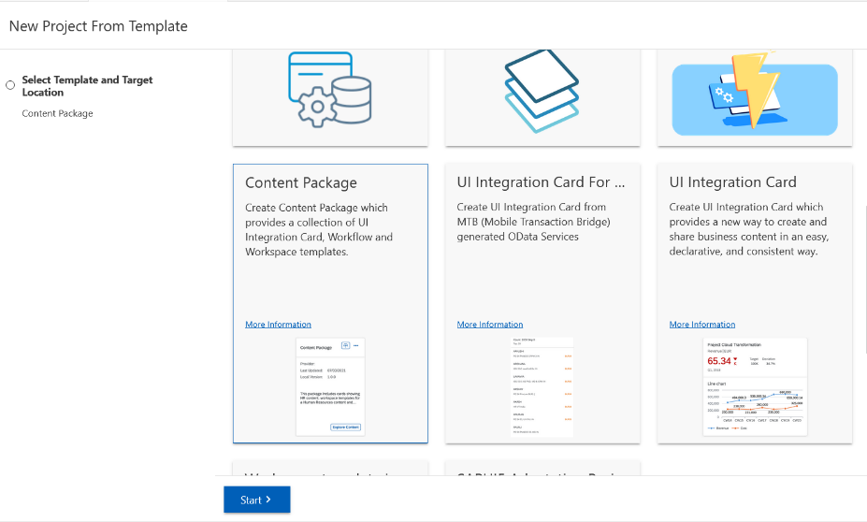
Creating a content package in BAS

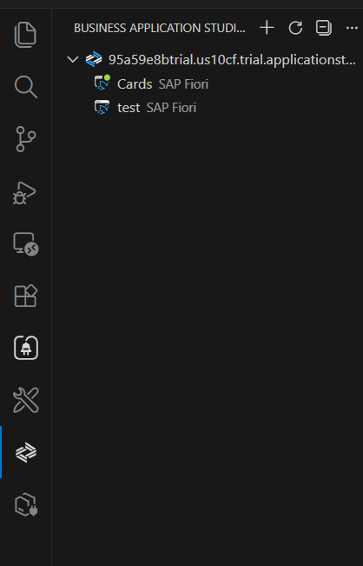

Creating the connection to the BAS through SSH
- If you don’t see it make sure you have
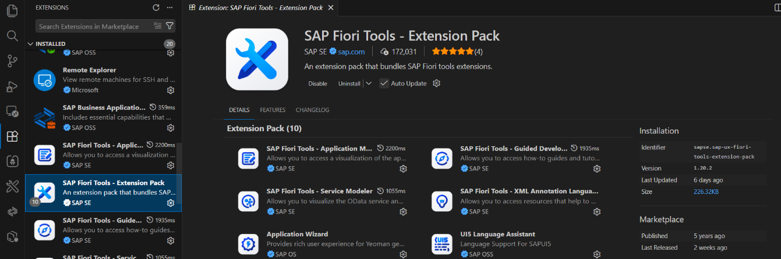
The extension pack installed

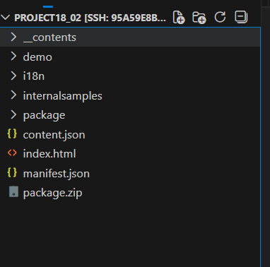
Start the right dev, after it’s started open in a new window.
- Open folder -> search for your created folder
and open

Create a new folder: demo
With another folder inside: called after the UI card you would like
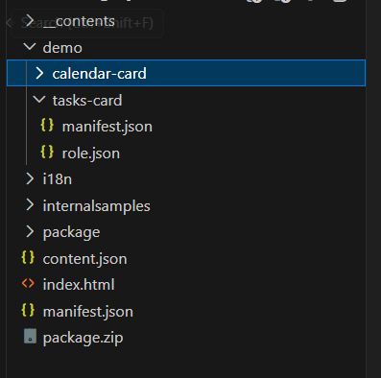
- Inside the UI card folder
  - Manifest.json
  - Role.json

Now we can fill in those files:
- Demo/UI-card/manifest.json
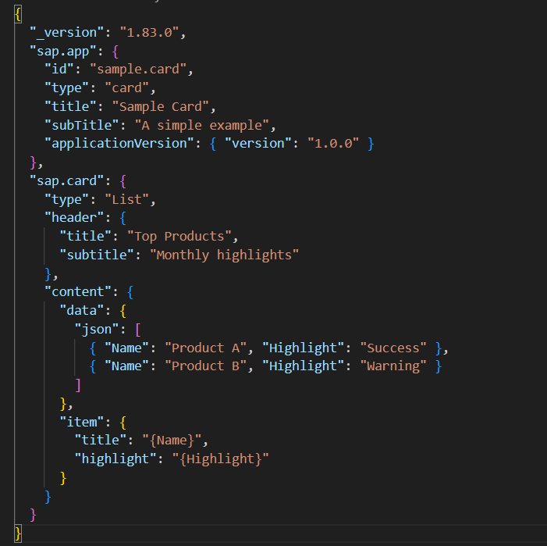
Here we will write the code of the UI card itself

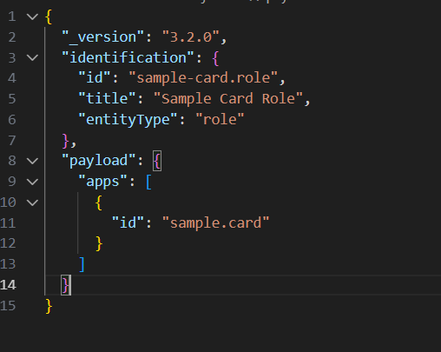
- Demo/UI-card/role.json

*Note: sometimes the role isn’t displayed in the work zone, try adding .app after the id: apps: “id”: “sample.card.app”

Make sure the apps.id is the same as the sap.app.id from the manifest file!!

- The manifest doesn’t need to be changed
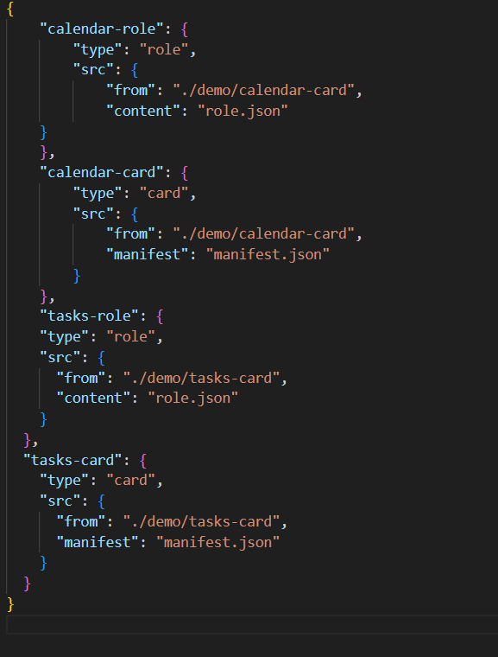
- The content.json needs to know which cards and roles are where so:

We can create a preview of the cards, normally you can easily click on content package preview but this function doesn’t work inside vs code -> The vs code SSH WebView cannot render SAP UI Card previews directly due to security and remote resource limitations, you can do this in the BAS, but for vs code we will need a work around. By creating
Creating a HTML to run it local
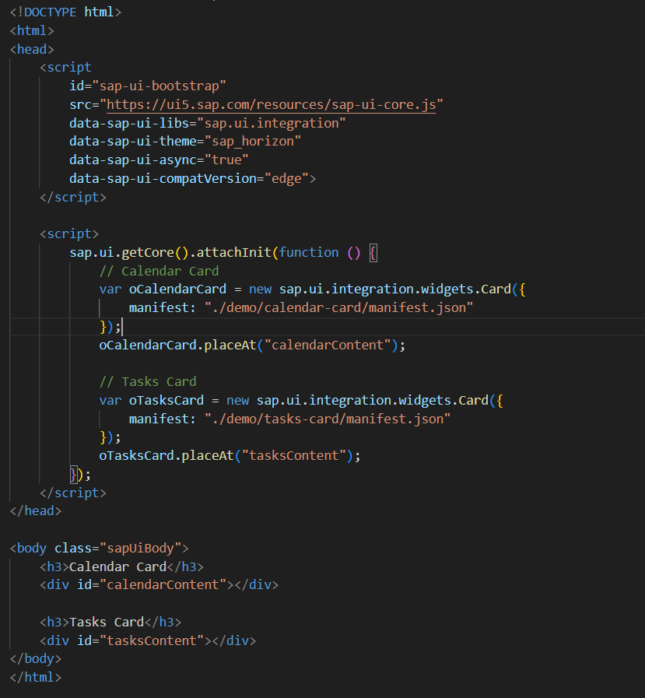

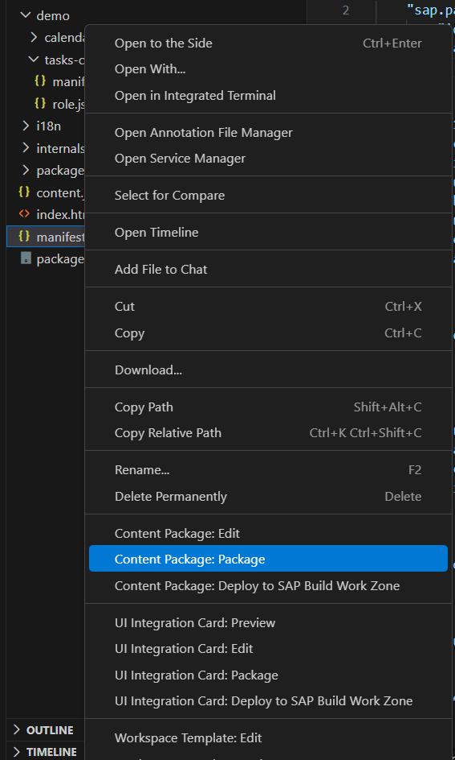
Then in the terminal: npx serve . -> y
This will give you an URL to the preview of the cards

Now deploying it to the SAP work zone:
On the root manifest file right click to package the content package
After that you can download the zip and place it where you want.

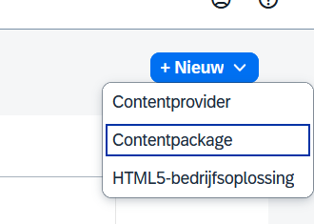
In the SAP work zone create a new content package
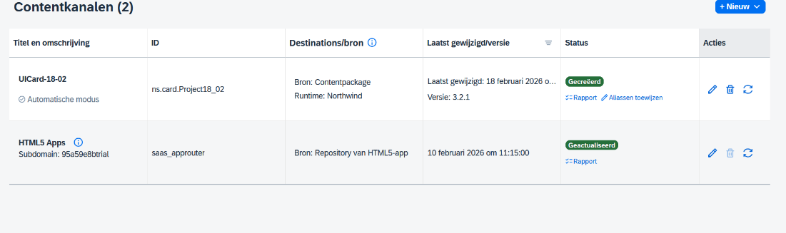

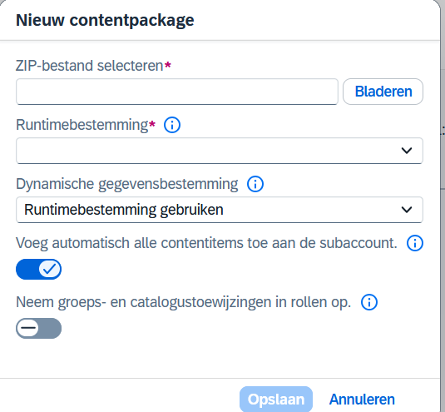

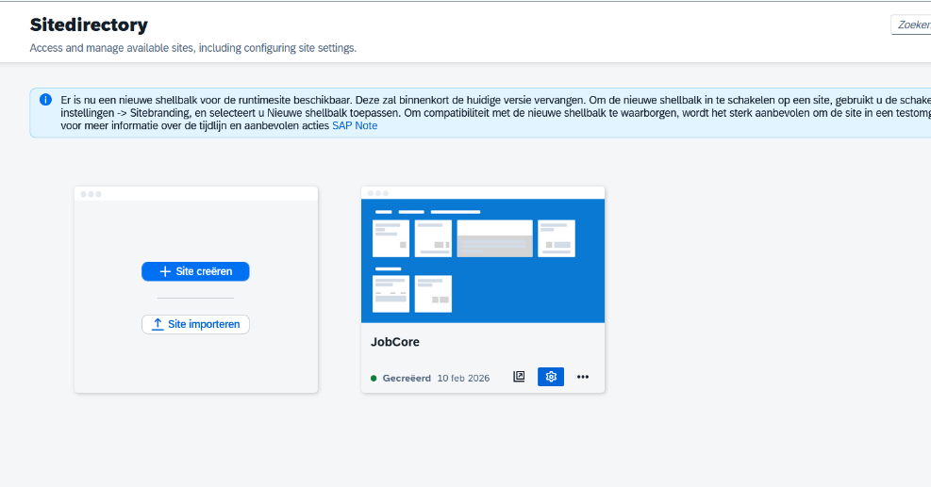
After completion we need to changes the roles:

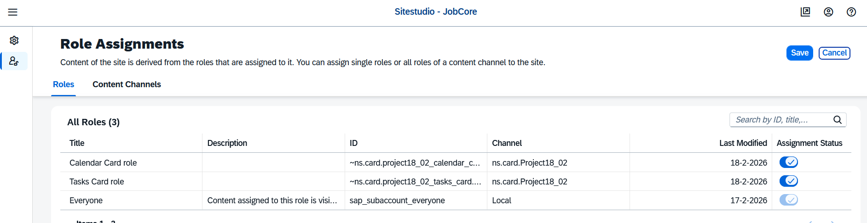

Make sure every role is visible.

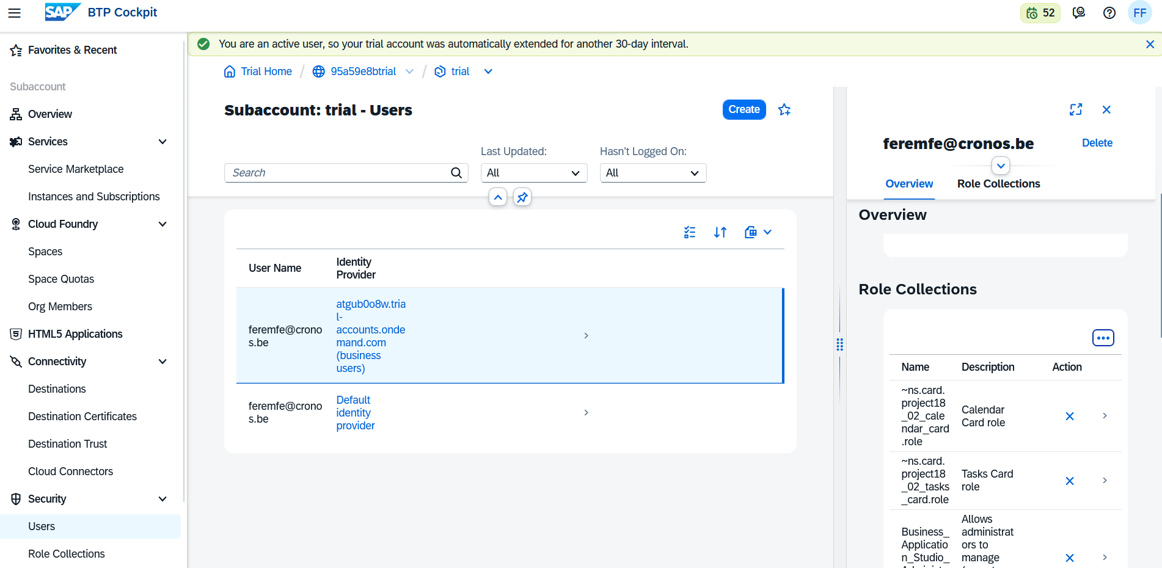
We also need to assign the roles inside the BTP

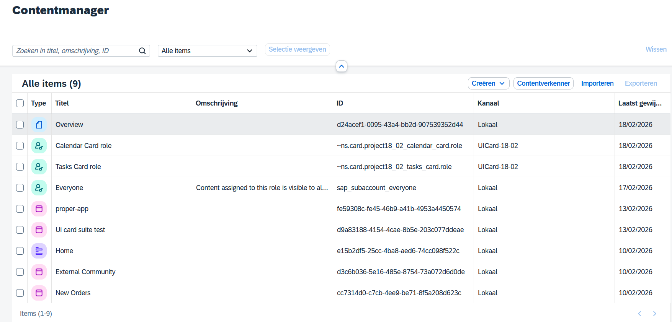
After that we need to add the cards to the page itself.

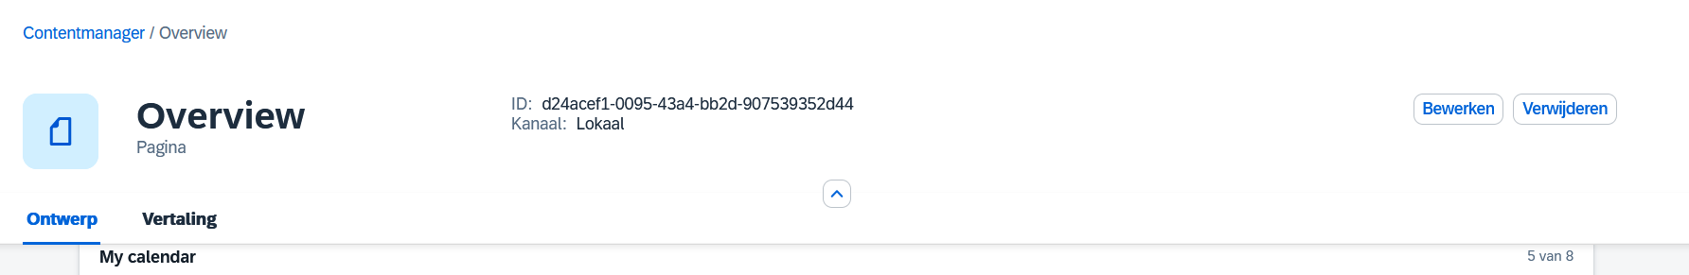

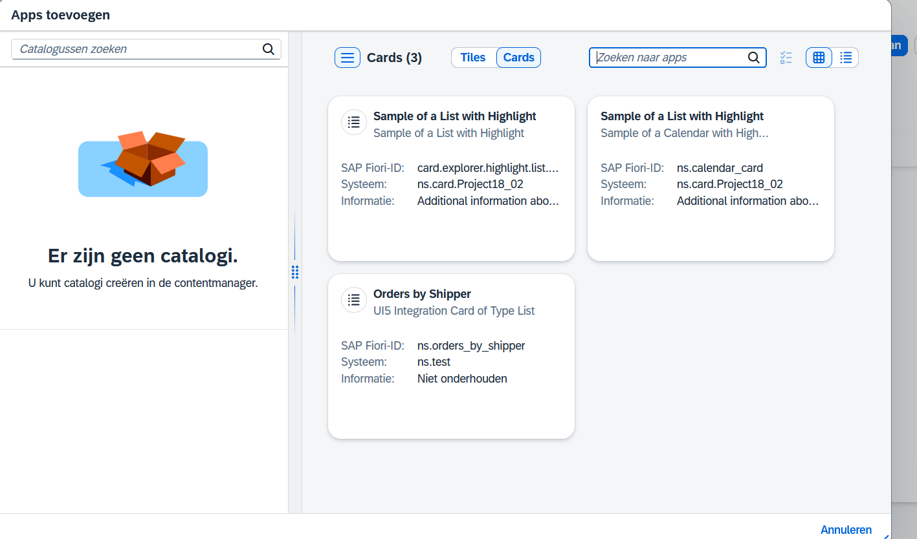

And it should be displayed.

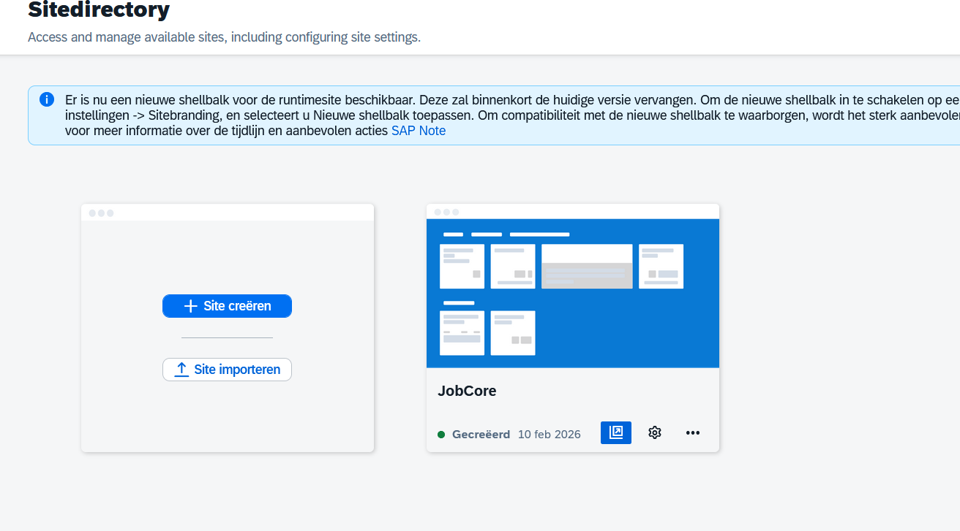

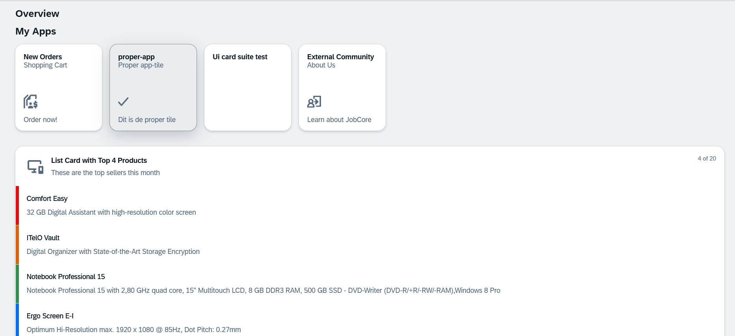

It is possible that the cards aren’t loaded yet, it could take some time. When you don’t have the patient to wait, go to an incognito browser and copy the url of the page in it.

Adding roles and spaces to the content package:

For the task we also need to add roles and spaces to the content package.
A space is a logical container for content. Think of it as a “room” or “workspace” where related workpages, cards, and apps live.
Purpose: It organizes content so users can navigate to it easily.
Scope: A space can contain multiple workpages, each with its own layout and set of cards.
Access control: Spaces can be assigned to roles, which determine who can see or interact with the content.
Here is the guide how to add those to the content package.

Before we worked with assigning a role to every card, from now on we will create a centralized role file (you can create multiple role files, with different rules).
For now we will just create one role file.
We will start with creating a new folder: cdm/src (two folders)
With in the src:
- A copy of the i18n
- A spaces folder
- A workpages folder
- A role.json file
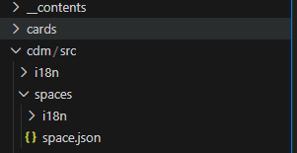
What are we putting in there
The Spaces folder;
Here we will create the spaces we want.

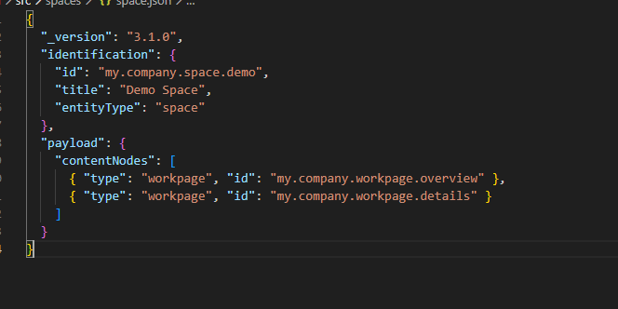
Example:

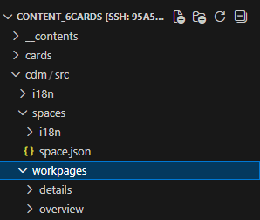
The Workpages folder:

–

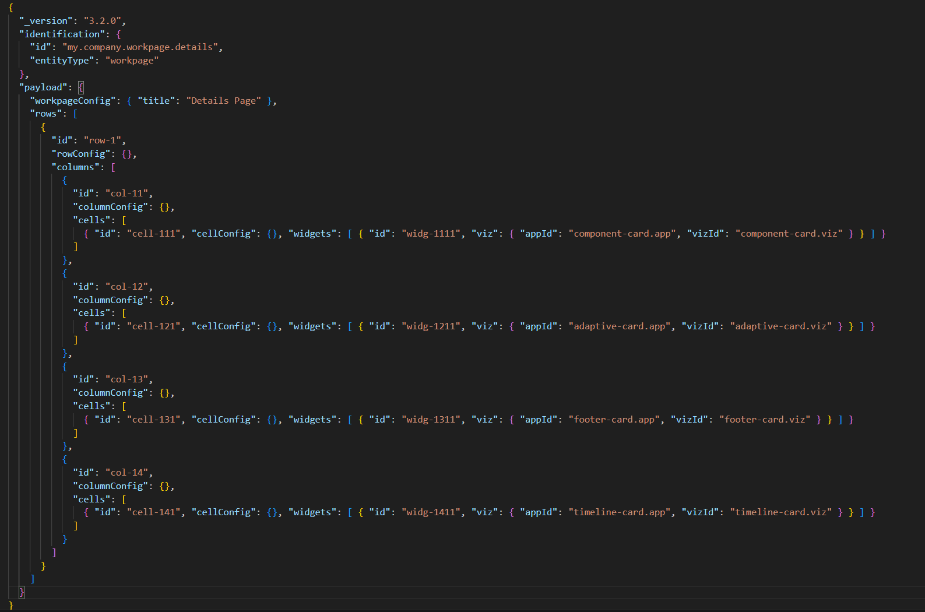
Examples:
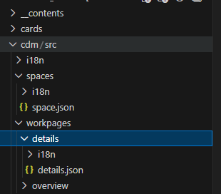

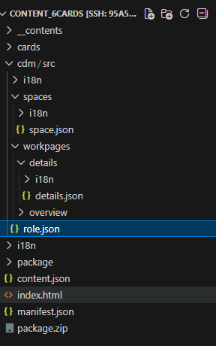
The Role file:
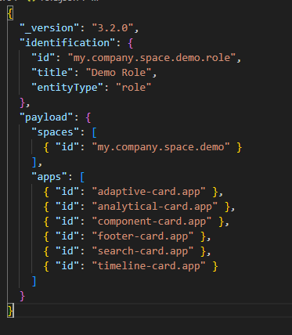
Example:

The content file is also updated:
The cards aren’t changed, except that the role.json file is removed for every card and combined in one single role file for the whole project.

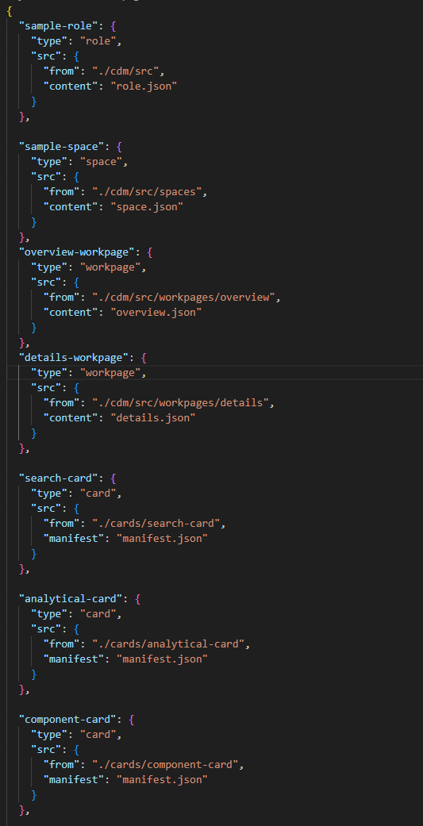
Example content file:
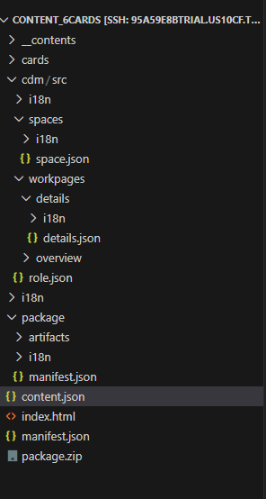

To test it locally add this script to the index.html I mentioned before

<script>
sap.ui.getCore().attachInit(function () {

const container = document.getElementById("cardsContainer");

// Load the space JSON
fetch("./cdm/src/spaces/space.json")
.then(res => res.json())
.then(space => renderSpace(space));

function renderSpace(space) {
// Optional: show space title
const spaceTitle = document.createElement("h1");
spaceTitle.innerText = space.identification.title || "Demo Space";
container.appendChild(spaceTitle);

// Loop over workpages
(space.payload.contentNodes || []).forEach(node => {
if(node.type === "workpage") {
const workpageFile = node.id.replace("my.company.workpage.", "") + ".json";
fetch(`./cdm/src/workpages/${workpageFile.replace(".json","")}/${workpageFile}`)
.then(res => res.json())
.then(workpage => renderWorkpage(workpage, container));
}
});
}

function renderWorkpage(workpage, container) {
// Workpage container
const pageDiv = document.createElement("div");
pageDiv.style.border = "2px solid #aaa";
pageDiv.style.padding = "15px";
pageDiv.style.marginBottom = "30px";
container.appendChild(pageDiv);

// Workpage title
if(workpage.payload.workpageConfig && workpage.payload.workpageConfig.title){
const title = document.createElement("h2");
title.innerText = workpage.payload.workpageConfig.title;
pageDiv.appendChild(title);
}

// Render widgets/cards
(workpage.payload.rows || []).forEach(row => {
const rowDiv = document.createElement("div");
rowDiv.style.display = "flex";
rowDiv.style.gap = "15px";
rowDiv.style.marginBottom = "15px";
pageDiv.appendChild(rowDiv);

(row.columns || []).forEach(col => {
(col.cells || []).forEach(cell => {
(cell.widgets || []).forEach(widget => {
const cardDiv = document.createElement("div");
cardDiv.style.flex = "1";
rowDiv.appendChild(cardDiv);

const appId = widget.viz.appId.replace(".app",""); // map to folder
const card = new sap.ui.integration.widgets.Card({
manifest: `./cards/${appId}/manifest.json`
});
card.placeAt(cardDiv);
});
});
});
});
}

});
</script>

After appending that to the html file, you can again run npx serve . to see a local version of the content package.

The rest keeps the same:
- Package the content package
- Download it
- Add it to SAP work zone
- Change roles in work zone, and BTP
- And see if it works

Debugging of the content package:
Debugging of the content package isn’t that ideal why?
- Because the preview can’t be loaded inside vs code, breakpoints inside vs code have no point because the JavaScript code isn’t performed.
Because we created a work around with the html file we can debug inside the browser itself, which is also not ideal.

Why vs code WebView can’t debug:
The uicard-dk extension’s preview runs inside a vs code WebView, which loads internal resources from the remote SSH server.
Over SSH, the WebView cannot access these internal files (403 forbidden), so the card never fully loads.
Without the card being loaded, there’s no JavaScript execution, which means breakpoints and the debugger in VS code don’t work.

Why the browser works:
When you serve your cards via a local HTTP server, the browser loads all manifests, JS, and resources correctly.
The cards fully run inside the browser environment.
Browser devtools give you:
- Breakpoints
- Console logs
- Network requests
- Step-through execution of card rendering

The debugging of the ui cards isn’t that well thought off, so I need to look a bit further in this.

To see something in the line of a debugger:
Enter this in the console of the local ui cards:
sap.ui.getCore().byId("__card1")
var oCard = sap.ui.getCore().byId("__card1");

The card1 -> is an example of a card id so you can change the number of the id to the one you like to debug.
After that we can go to the debugger tab of the console and now we see the html code we created. We can place a breakpoint where we want to.
And follow the process of the debugging.

What went wrong when deploying the content package:
- Space wasn’t showing in the work zone
  - I forgot to add the space to the role file
  - Then I forgot to add the workpages to the role file
- Build Error: Enoent space.json
  - I placed the space in a deeper folder so my path wasn’t correct anymore
- It were mostly stupid mismatches, like;
  - Forgot to change the roles inside the work zone
  - Creating a role file, with the wrong destinations
  - Forgetting the version of the manifest files.

Setting up a database
https://community.sap.com/t5/technology-blog-posts-by-members/creation-of-sap-hana-database-instance-in-sap-btp-trial/ba-p/14087014

Creating a cap project
- npm install -g @sap/cds-dk
- cds init
- npm install
- cds add hana
- cds add nodejs

- npm install @cap-js/hana
make sure you are loged in: cf login
- cds deploy --to hana
- cds add mta
- mbt build
- cf deploy mta_archives/<your-mta>.mtar

after setting up the environment inside the btp with the hana cloud shit you can
- cf deploy mta_archives/calendar24_2_1.0.0.mtar

